Problem Solving III
Assignment 1
Areesha Raheel
55039
BSIT-6
________________________________________________________________
B / B+ Trees
1. A library uses a B+ Tree to index books by ISBN for fast search/range queries.
Task:
Write a program to:
- Insert books (ISBN, Title) into a B+ Tree (order=3).
- Search for a book by ISBN.
- Print all books in a range (e.g., ISBN 50-100).
Input:
insert 45 "Book1"
insert 30 "Book2"
insert 70 "Book3"
search 30
range 25 50
Expected Output:
Found: Book2
Range results: [30 Book2, 45 Book1]

CODE:
#include <iostream>
#include <vector>
#include <algorithm>
using namespace std;

class BPlusTree {
struct Node {
bool isLeaf;
vector<int> keys;
vector<string> values;
vector<Node*> children;
Node* next;

Node(bool leaf = false) {
isLeaf = leaf;
next = nullptr;
}
};

Node* root;
int order;

public:
BPlusTree(int ord = 3) {
root = new Node(true);
order = ord;
}

void insert(int key, string value) {
Node* leaf = findLeaf(root, key);

auto it = lower_bound(leaf->keys.begin(), leaf->keys.end(), key);
int pos = it - leaf->keys.begin();

leaf->keys.insert(it, key);
leaf->values.insert(leaf->values.begin() + pos, value);

if (leaf->keys.size() >= order) {
splitLeaf(leaf);
}
}

void search(int key) {
Node* leaf = findLeaf(root, key);

for (int i = 0; i < leaf->keys.size(); i++) {
if (leaf->keys[i] == key) {
cout << "Found: " << leaf->values[i] << endl;
return;
}
}

cout << "Not Found" << endl;
}

void rangeSearch(int start, int end) {
Node* leaf = findLeaf(root, start);

cout << "Range results: [";

bool first = true;

while (leaf != nullptr) {
for (int i = 0; i < leaf->keys.size(); i++) {
int key = leaf->keys[i];

if (key >= start && key <= end) {
if (!first) cout << ", ";
cout << key << " " << leaf->values[i];
first = false;
}

if (key > end) {
cout << "]" << endl;
return;
}
}

leaf = leaf->next;
}

cout << "]" << endl;
}

private:
Node* findLeaf(Node* node, int key) {
if (node->isLeaf)
return node;

int i = 0;
while (i < node->keys.size() && key >= node->keys[i])
i++;

return findLeaf(node->children[i], key);
}

void splitLeaf(Node* leaf) {
Node* newLeaf = new Node(true);

int mid = order / 2;

newLeaf->keys.assign(leaf->keys.begin() + mid, leaf->keys.end());
newLeaf->values.assign(leaf->values.begin() + mid, leaf->values.end());

leaf->keys.resize(mid);
leaf->values.resize(mid);

newLeaf->next = leaf->next;
leaf->next = newLeaf;

if (leaf == root) {
Node* newRoot = new Node(false);

newRoot->keys.push_back(newLeaf->keys[0]);
newRoot->children.push_back(leaf);
newRoot->children.push_back(newLeaf);

root = newRoot;
}
}
};

int main() {
BPlusTree tree(3);

tree.insert(45, "Book1");
tree.insert(30, "Book2");
tree.insert(70, "Book3");

tree.search(30);

tree.rangeSearch(25, 50);

return 0;
}

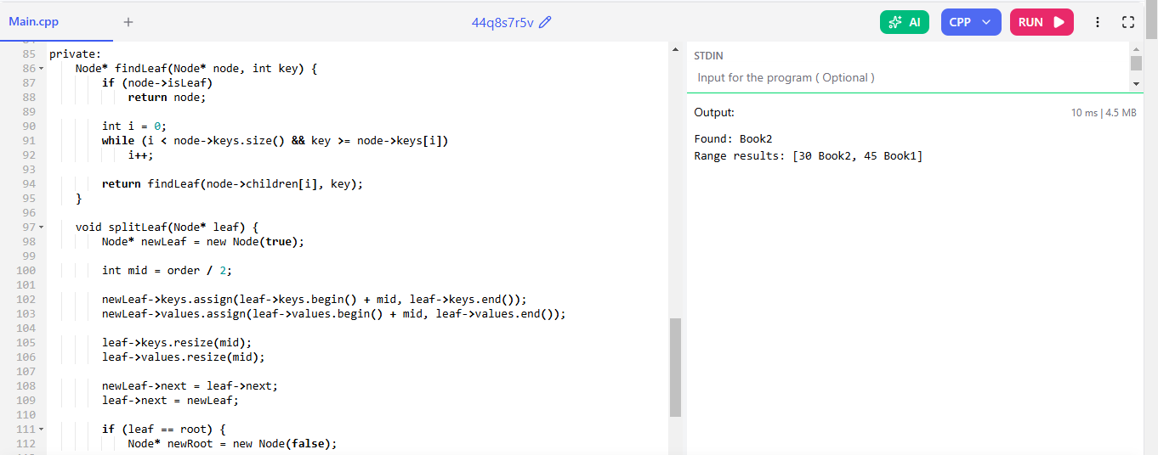

2. Store employee records (ID, Name) in a B-Tree. Find employees in a given ID range.
Input:
insert 101 "Alice"
range 100 150
Expected Output:
[101 Alice]

CODE:
#include <iostream>
#include <map>
using namespace std;

class EmployeeBTree {
map<int, string> employees;

public:
void insert(int id, string name) {
employees[id] = name;
}

void rangeSearch(int start, int end) {
cout << "[";

bool first = true;

for (auto &emp : employees) {
if (emp.first >= start && emp.first <= end) {

if (!first) cout << ", ";

cout << emp.first << " " << emp.second;
first = false;
}
}

cout << "]" << endl;
}
};

int main() {
EmployeeBTree tree;

tree.insert(101, "Alice");

tree.rangeSearch(100, 150);

return 0;
}

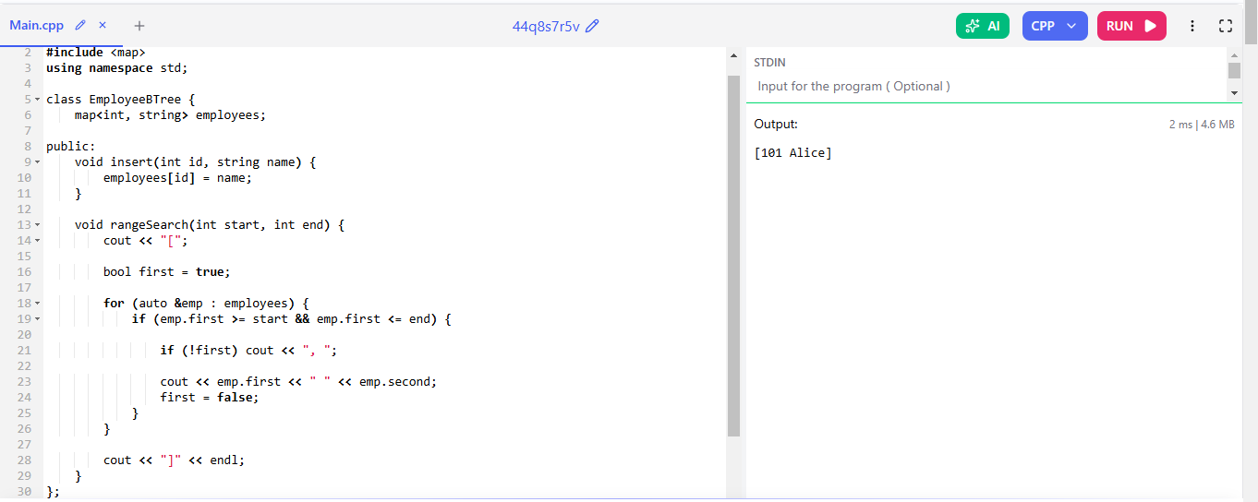

3. Simulate a B-Tree for disk block allocation. Find the block containing a file.
Input:
insert 5 "fileA.txt"
search 5
Expected Output:
Block 5: fileA.txt

CODE:
#include <iostream>
#include <map>
using namespace std;

class DiskBTree {
map<int, string> blocks;

public:
void insert(int block, string filename) {
blocks[block] = filename;
}

void search(int block) {

if (blocks.find(block) != blocks.end()) {
cout << "Block " << block << ": " << blocks[block] << endl;
}
else {
cout << "Block not found" << endl;
}
}
};

int main() {

DiskBTree tree;

tree.insert(5, "fileA.txt");

tree.search(5);

return 0;
}




